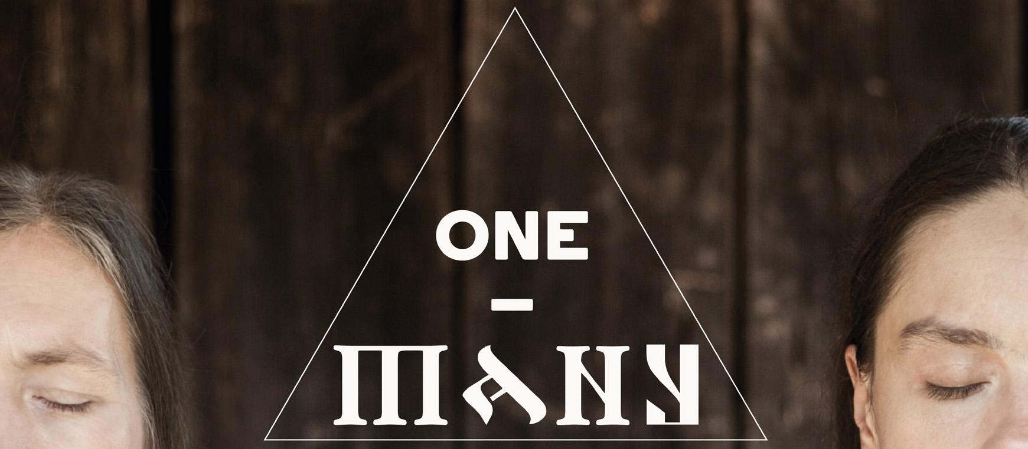
One – Many. The Languages of Podlaskie's Temples.
Karolina Cicha – vocal, accordion, rithual drums, piano, sampler, ethnical instruments
Elżbieta Rojek – vocal, dance, harmonium, religious instruments, traditional percussion stick called „devil violin”

The Concert relates especially to the multicultural sacral traditions of region Podlaskie located in the very northeast of Poland, home region of Karolina Cicha. It is a symbolic border between the East and the West, reflecting the ethnic diversity of Eastern Europe. The sacral music structure is very interesting there: some religions created rich performing traditions (such as polyphonic Orthodox songs or Klezmer scales of the Sabbath singing), the other (like Tartar Islam) have its own traditions of melodeclamation of the Holy Book, yet another have gathered various music styles within centuries (Catholicism: from Gregorian chant, through classical music to gospel). The concert tries to combine this mosaic into a musically coherent i impressible program. The music will be complemented by a number of sacred languages: Old Church Slavonic, Latin, Arabic, Hebrew and Polish. The lirycs' selection is focused around the most joyful and bright elements of each religion, their affirmations in forms of praises, honor, gratitude.
KAROLINA CICHA - Singer, multi-intrumentalist, actress and composer. She sings and plays many instruments simultaniously. Her career started with solo concerts and in 2009 she launched a rock band. In 2013 her interests moved towards ethno music. Together with Bart Pałyga she made an album called '9 Languages', that is a compilaton of traditional songs in various languages spoken in north-east of Poland. For the album they were awarded GRAND PRIX and AUDIENCE PRIZE on 'New Tradition' - Polish Radio Folk Festival in 2009. Since than, she performed on a number of folk festivals worldwide i.e.: 'TFF Rudolstadt' (Germany); FMM Sines Festival' (Portugal); 'Isole che Parlano' (Sardinia); 'Euroradio Folk Festiwal' (Sweden); 'World Music Fest' (Chicago, USA); 'Music mela' (Pakistan); 'Cheoyong Culture Festival' (South Korea). In 2014, she was awarded by polish Ministry of Culture and National Heritage with “Młoda Polska” grant. She was an official artist of the year selection at 2015 WOMEX – the biggest World Music Festival. Between 2007 and 2009, alongside with her music, she has also worked in 'Gardzienice' theatre, playing and singing the title roles in performances based on reconstructions of antique music. She holds a PhD in humanities (history of literature).
ELŻBIETA ROJEK - Actress, singer and choreographer. Working with musicality in theater to connect with movement and word. For many years, Rojek was lead actress ofCenter of Theater Practices Gardzienice. Co-founder of Theatre Association Chorea. Her singing career began in the cult Polish folk music band 'Orchestra of St. Nicholas'. The team explored Lemko and Hutsul musical traditions, and their records won awards in leading ethnic music competitions including the Polish Radio Folk Phonogram of the Year Award in 2006. As an actress she has performed at the most prestigious festivals in the world, such as the Fringe Festival, Edinburgh, (with "Puppet. The Book of Splendor," directed by award-winning Pawel Passini;); Women monodrama festival "Maria", the National Theater of Ivan Franko, Kiev (with "Monologue" dir. Daniel Bird), 2006 - High Fest (Yerevan); Budapest, Shinhaz Merlin Theatre; USA, Los Angeles, The Getty Centre (with Metamorphoses dir. Wlodzimierz Staniewski); Stanford, Stanford University; Trajan's Forum, Rome (Metamorphoses with dir. Wlodzimierz Staniewski); Spain, Zaragoza, Museum of Modern Art Pablo Serrano; USA, Albequerque, University of New Mexico.
Booking: Karolina Cicha +48 505539120 / cichagra@gmail.com / karolinacicha.eu
The concert was created within the artistic grant of Marshal of the Podlaskie Voivodship.

